MODULE:1

1.What is software? What is software engineering?

->Software is a set of instructions, data or programs used to operate computers and execute specific tasks.

->Software is a program or set of programs containing instructions that provide the desired functionality. Engineering is the process of designing and building something that serves a particular purpose and finds a cost-effective solution to problems.

2.Explain types of software

->There are 5 types of software.

1.Application software

->Software that performs special functions or provides functions that are much more than the basic operation of the computer is known as application software.

ex->Amazon, Flipkart

2.System software

->These software programs are designed to run a computer's application programs and hardware. System software coordinates the activities and functions of the hardware and software.

Ex->Android ,IOS

3.Driver software

->this software is often considered a type of system software. Device drivers control the devices and peripherals connected to a computer, helping them perform their specific tasks.

Ex->Audio, video driver

4.Middle software

->The term middleware describes software that mediates between application and system software or between two different kinds of application software. For example, middleware lets Microsoft Windows talk to Excel and Word.

5.Programming software

->Computer programmers use programming software to write code. Programming software and programming languages, such as Java or Python, let developers develop, write, test and debug other software programs.

Ex-> Eclips

3.What is SDLC? Explain each phase of SDLC?

-> Software development life cycle (SDLC) is a structured process that is used to design, develop, and test good-quality software.

1.Planning->The software is deployed to a production environment and made available to end-users.

2.Analysis->This phase involves gathering information about the software requirements from stakeholders, such as customers, end-users, and business analysts.

3.Designing-> In this phase, the software design is created, which includes the overall architecture of the software, data structures, and interfaces.

4.Implemention->The design is then implemented in code, usually in several iterations, and this phase is also called as Development.

5.Testing->The software is thoroughly tested to ensure that it meets the requirements and works correctly.

6.Maintenanse->This phase includes ongoing support, bug fixes, and updates to the software.

4.What is DFD? Create a DFD diagram o

-> A Data Flow Diagram (DFD) is a traditional visual representation of the information flows within a system.

SELECT SIZE

ADD TO CART

CHECK IN DATABASE

CHOOSE HOME ADDRESS

CHOOSE PAYMENT METHOD

ENTER OTP

DATA BASE

ENTER MOBILE NUMBER

BOOK PRODUCT

5. What is flowchart? Create a flowchart to make addition of two members

->A flowchart is a type of diagram that represents an algorithm, workflow or process. The flowchart shows the steps as boxes of various kinds, and their order by connecting the boxes with arrows.

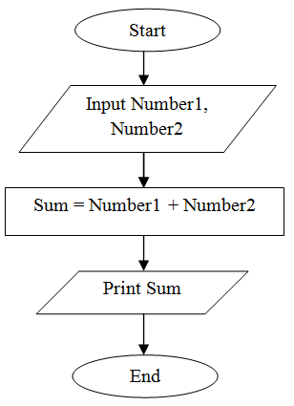

6. What is use case Diagram? Create a use case on bill payment on payment

->Use-case diagrams describe the high-level functions and scope of a system. These diagrams also identify the interactions between the system and its actors.

FINISH

ENTER OTP

ENTER MOBILE NUMBER

ENTER PASSWORD

ENTER BANK ACCOUNT NUMBER

CHOOSE PAYEMENT METHOD

ADD TO CART